VULNERABILITY FINDINGS

Tile: SQL Injection (Broken Authentication) in the login functionality Functionality.
Affected Endpoint: https://vulnbank.org/login
Severity: Critical
1. Vulnerability Identified (The Flaw)
The login functionality of the VulnBank application is vulnerable to SQL Injection.
Root Cause:
- User-supplied input (username/password) is directly embedded into SQL queries
- No use of:
  - Parameterized queries
  - Input sanitization
This allows attackers to manipulate the SQL query logic.

2. Execution (How the Attack Was Performed)
examine this screenshot:
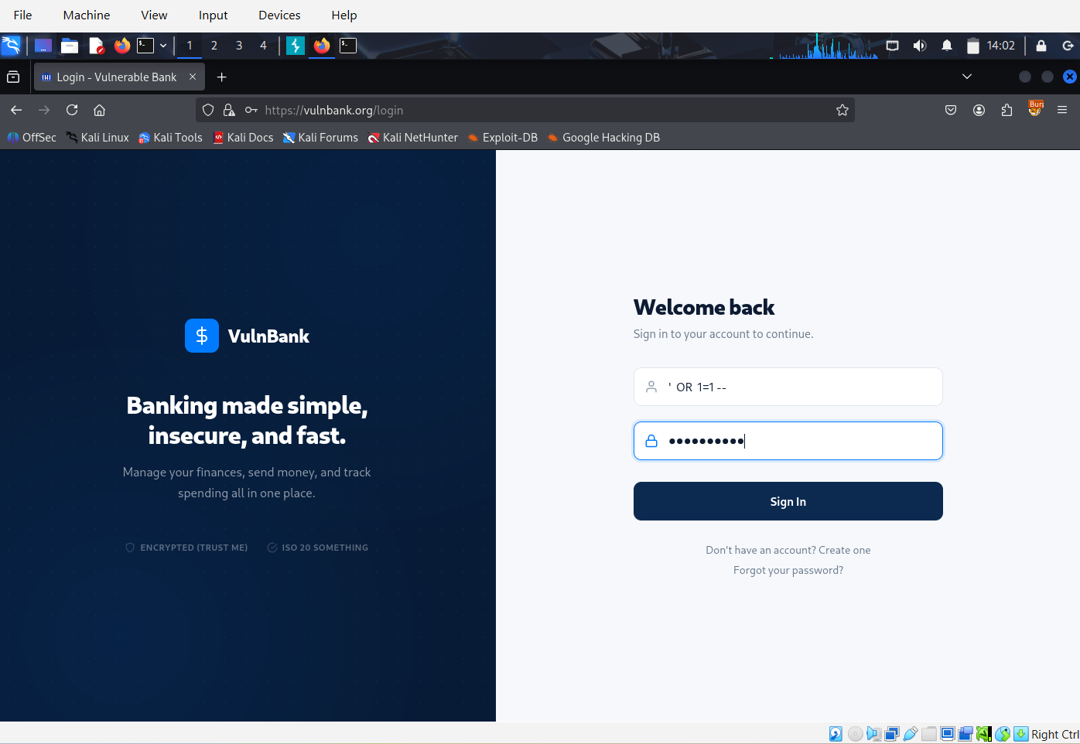
- A malicious payload was injected into the username field:
"username": "' OR 1=1--",
"password": "Randompassword "
What this does:
- ' → breaks out of the query string
- OR 1=1 → forces condition to always be TRUE
- -- → comments out the rest (including password check)

3. Proof of Exploitation (Evidence)
Evidence 1: Successful Login Response
From Burp Suite response:
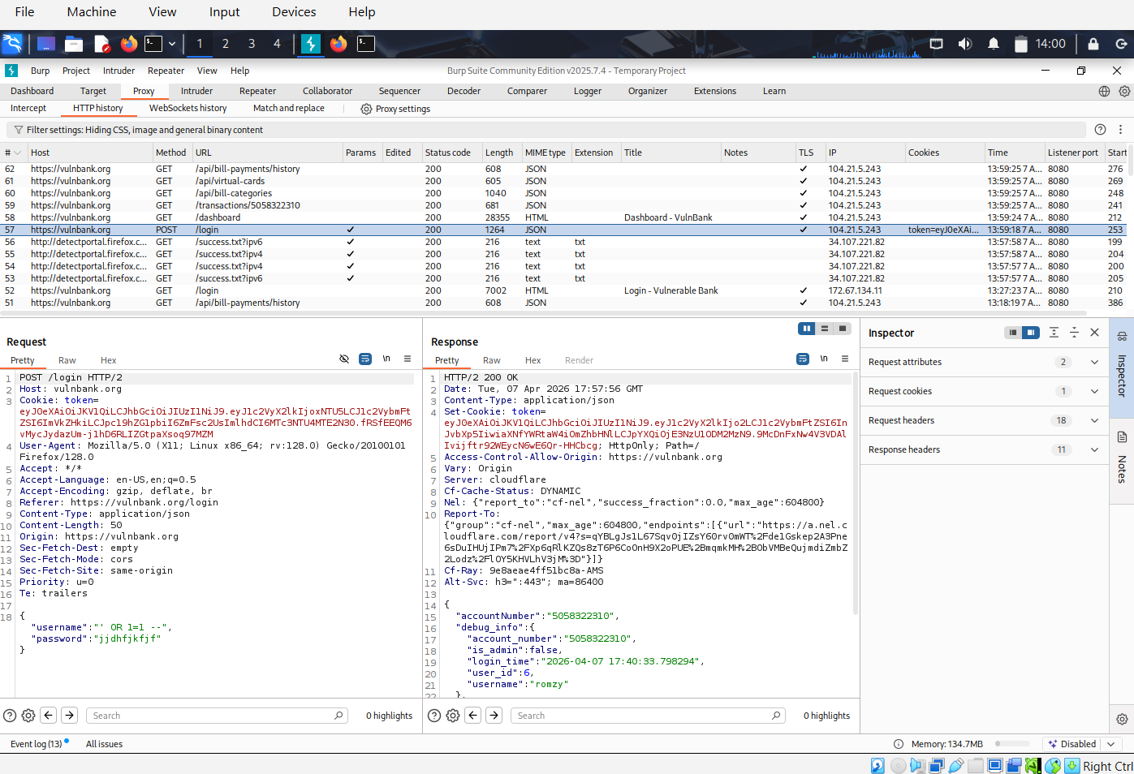
"username": "romzy",
"user_id": 6,
"is_admin": false
👉 This confirms:
- Authentication was bypassed without valid credentials
- The system returned a valid user session

Evidence 2: HTTP Status Code
- Response: HTTP/2 200 OK
Indicates:
- The request was accepted
- Authentication logic was successfully bypassed

Evidence 3: Dashboard Access
From the vulnbank dashboard screenshot:
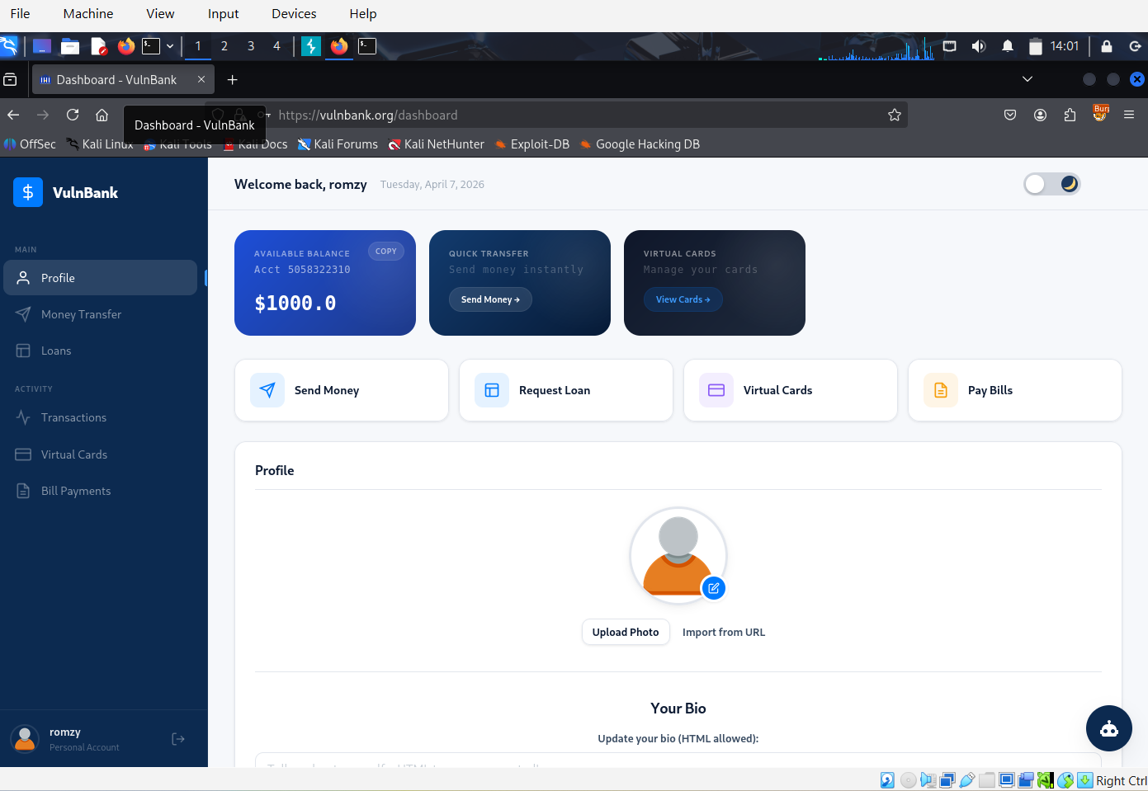

I was logged in successfully as “romzy” with Full access to: Account balance ($1000.0), Transactions, Banking features etc.
This proves:
- Unauthorized access to a valid user account
4. Impact of this vulnerability
This vulnerability allows attackers to:
- Bypass authentication completely
- Gain unauthorized access to user accounts
- Potentially access sensitive financial data
- Perform actions as legitimate users
Severity: CRITICAL

5. Remediation
Use of Parameterized Queries
DO NOT build queries like this:
SELECT * FROM users
WHERE username = '$username' AND password = '$password';

Use Prepared Statements:
Example :
SELECT * FROM users
WHERE username = ? AND password = ?;
Or (depending on language/framework):

Additional Security Controls
- Hash passwords (e.g., bcrypt) — never store plain text
- Input validation (reject SQL meta-characters where unnecessary)
- Deploy a Web Application Firewall (WAF)
- Disable detailed SQL error messages in production
- Apply least privilege to database accounts

6. Verification
After implementing the fix, Re-test using the same payload:
' OR 1=1--
Expected result:
- Login should fail
- No authentication bypass should occur

Conclusion
The presence of SQL Injection in the authentication mechanism represents a critical security flaw that compromises the entire application. Immediate action is required to prevent unauthorized access and protect user data.

